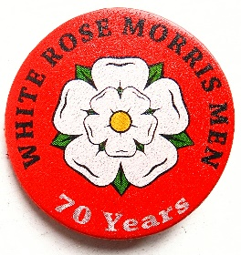
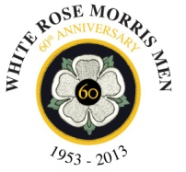

The Cliff Barstow Jig Competition 2024
at Whitby Folk Week

In memory of founder member Cliff Barstow, White Rose Morris Men sponsor an annual jig competition.

A trophy will be awarded to the winner.
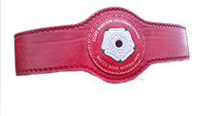

The competition will take place in the Spa Foyer on Tuesday 20th August
4.30pm

ENTRY IS FREE

Entry form overleaf - more forms can be
downloaded from the White Rose website
whiterosemorrismen.org.uk

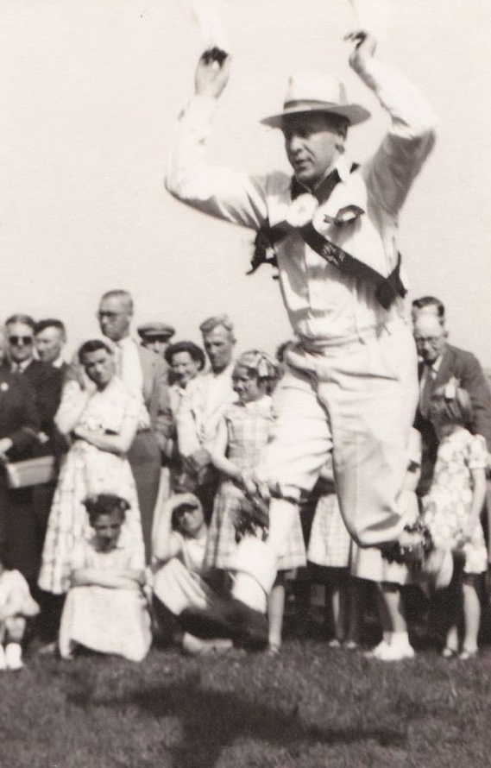

Dancers should be prepared to dance a standard Cotswold jig of their choice as well as one from the following list:

Old Tom of Oxford: Bampton
The Nutting Girl (Field Town)
I’ll Go and Enlist (Sherborne)
Ladies' Pleasure: Bledington

Music should be from a single musician – for the compulsory jig this musician will be nominated by White Rose. For the own-choice jig you should supply your own musician.

Your name:…………………………………………………
Your team (optional):…………………………………………
Your compulsory dance choice:
…………………………………………….……………………………
Your own choice dance and tradition
(this dance will only be used if selected as a finalist):
…………………………………………………………………………

Your contact phone number:…………………………………..

Please return the form by email to bagman@whiterosemorrismen.org.uk
or hand it to one of White Rose Morris Men

